Roll No: 422171

Name: Lahari. K

Section: A

Assignment: 05

Task1: Using SSH command execute the three programs on two different machines.

Execution:

Connected to IP address 172.50.1.217 (system no. 69 in AI lab) from the system with system no. 70

via ssh.

Executed programs 2child.c, shortest.c, sorting.c (originally present on system no. 69) from system no. 70.

Also executed the same programs on system no. 69.

Output screenshots:

On system no. 70 -

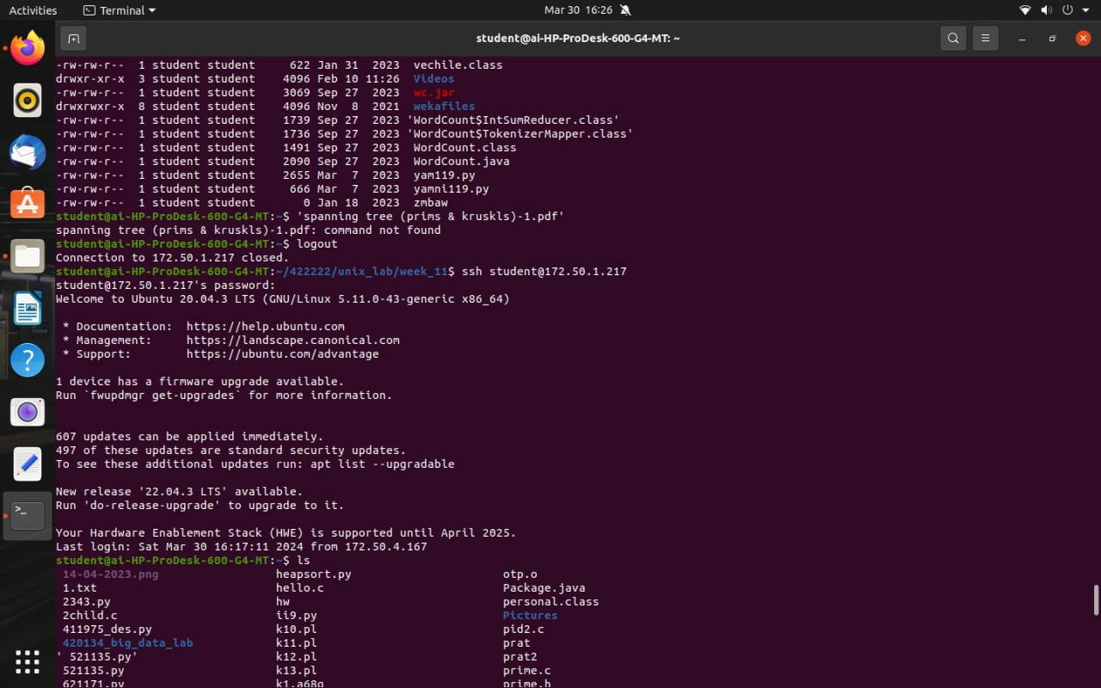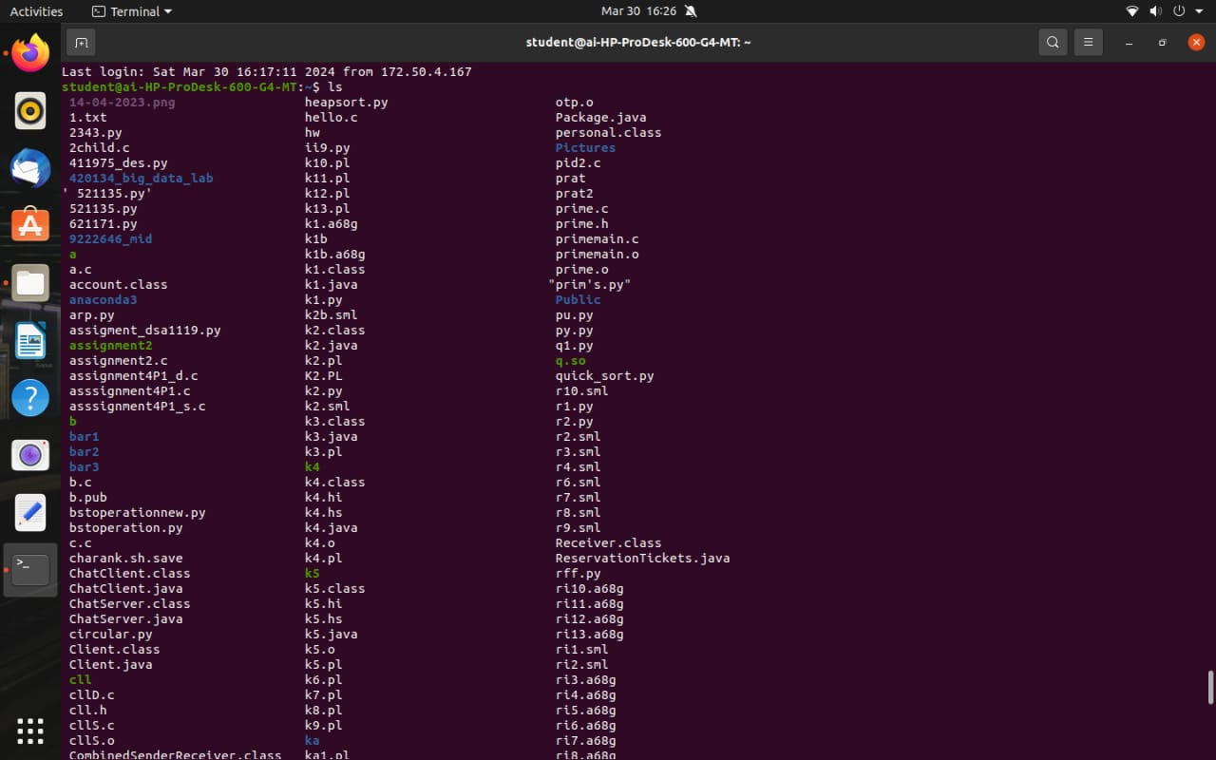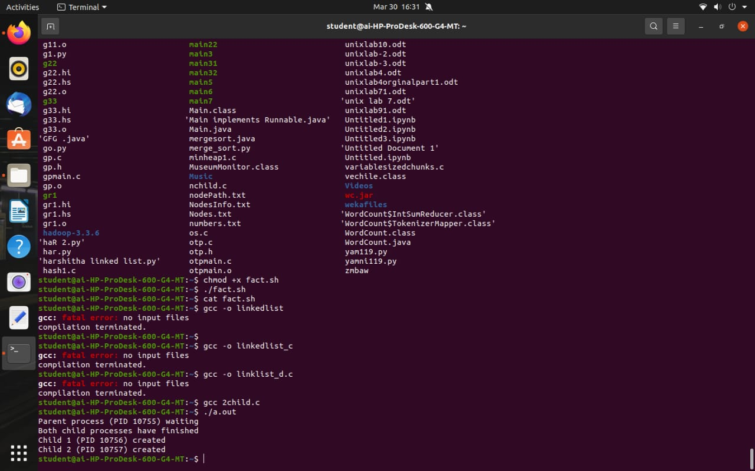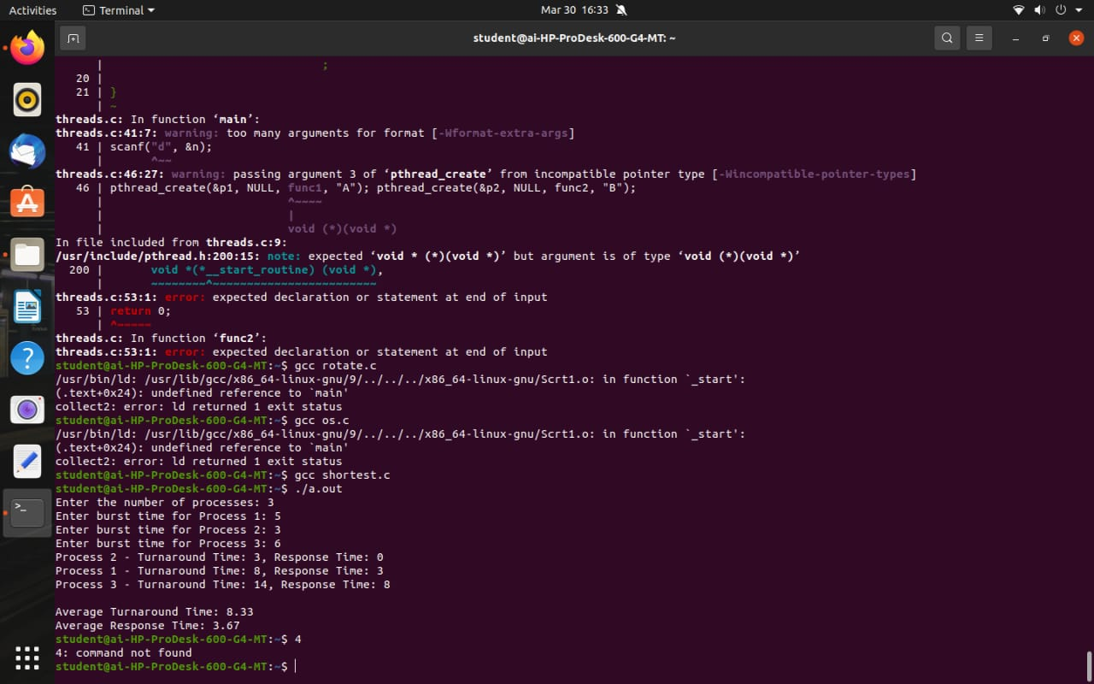 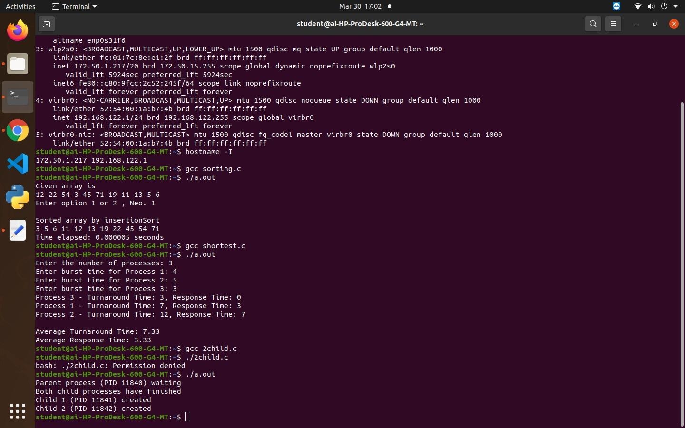

On system no. 69 -

